Data Management Guide

WMP Phase II

# Introductions

This document has been designed specifically for our watershed management project Phase II, this comprehensive guide aims to establish standardized naming conventions and folder structures. With the project encompassing a vast array of datasets and users, the guide serves as a crucial tool for maintaining consistency, preventing duplications, and streamlining data retrievals. Accompanied by a suite of ArcGIS-based Python scripts, this guide offers step-by-step instructions for effective dataset management, ensuring seamless integration and accessibility across the project.

# Folder Structure

Within your user directory there should be the base folder WMP_Phase_II inside the base folder you can start with client/community name. for each of the client/community or let’s say study area there should be the minimum directories and files as shown in the table Folder Structures. Note:- you may have some additional directory/file depending upon your study for example ArcHydro files, please maintain it properly and describe it in ReadMe.txt file.

## Client/Community Directory

**Community_ Type**

Community: no spaces in name, capitalize each word, separate by underscore

Type: either City or County

Example:

PalmBeach_County

|  |  |  |
| --- | --- | --- |
| **SN** | **Name** | **Description** |
| 1 | ArcGIS_Projects | To store all the ArcGIS project files, no any conventions for the files inside this directory but you have to write short descriptions about files/folder in Folder_Details.xls. |
| 2 | Cascade | To store inputs, models and outputs for modelling, no any conventions for the files inside this directory but you have to write short descriptions about files/folder in Folder_Details.xls. |
| 3 | Documents | To store all the documents/tables used for reference or prepared for reporting, no any conventions for the files inside this directory but you have to write short descriptions about files/folder in Folder_Details.xls. |
| 4 | client/community name.gdb | To store all the vector files used for preparing maps, you should strictly follow the naming conventions for the files as described in the table Vector naming conventions. |
| 5 | client/community name | To store all the mosaics of raster files (rasters covering whole study area) used for preparing maps, you should strictly follow the naming conventions for the files as described in the table Raster naming conventions. |
| 6 | HUC12s | To store all the Huc-wise of raster files (rasters clipped with HUC12s boundaries) used for preparing maps, you should strictly follow the naming conventions for the sub-directories and files as described in the table Raster naming conventions. Please note that inside this directory there will be multiple subdirectories representing each individual HUC12s, please refer to naming HUC12s directories. |
| 7 | Maps | To store all the png/jpeg files (generated maps), no any conventions for the files inside this directory but you have to write short descriptions about files/folders in Folder_Details.xls. |
| 8 | Temp | To store any intermediate files if you have, no any conventions for the files inside this directory as well as no mandatory descriptions but you can prepare ReadMe files if you think it’s relevant. |
| 9 | ReadMe.txt | To describe folders. |
| 10 | Folder_Details.xls | For details descriptions about the files inside the folders. |

Table 1: Folder Structures

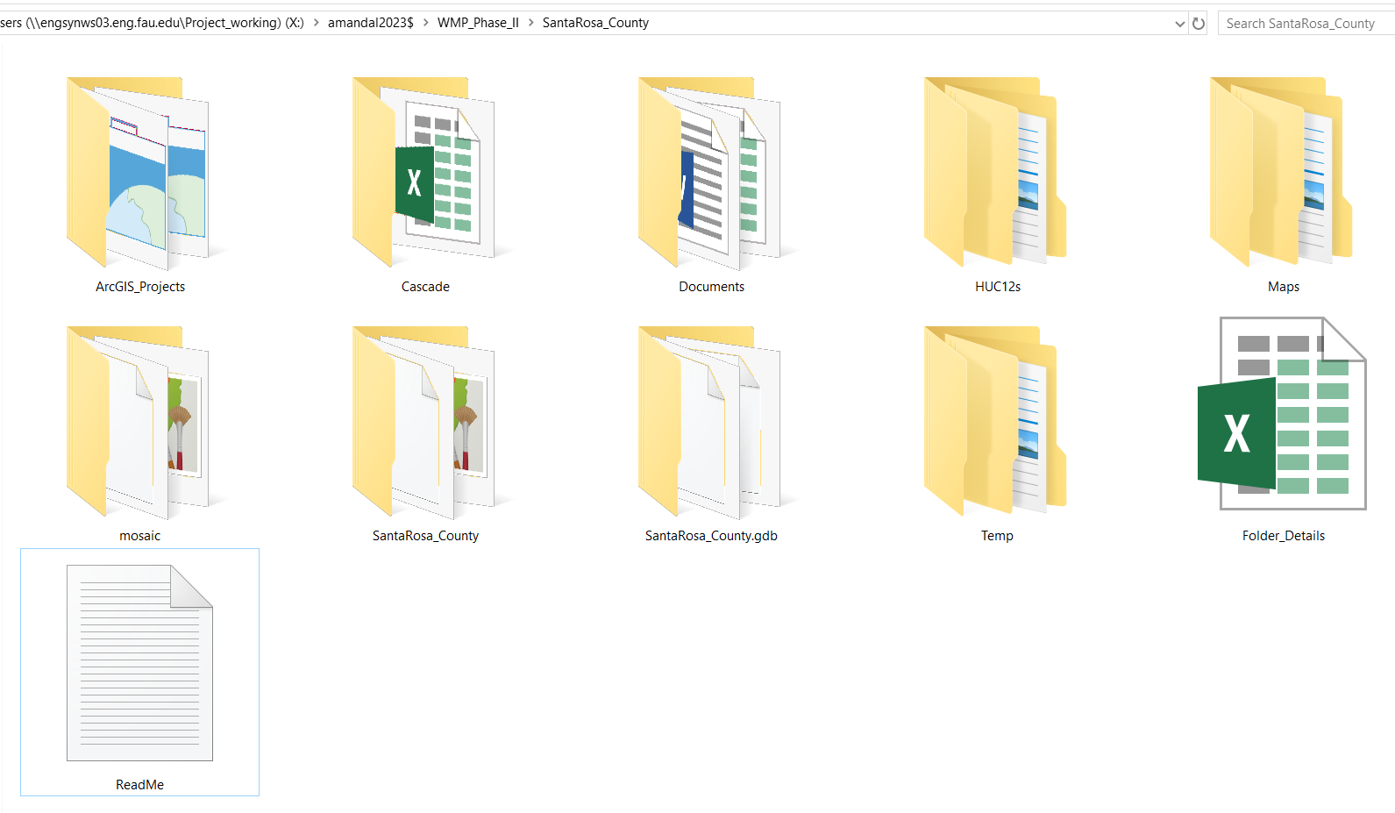

Figure 1: Folder Structures

## HUC12s directory

Create a child folder for each 12-digit HUC sub watershed intersecting the region of interest within the subfolder HUC12s. Note: a HUC12 that intersects multiple communities should appear more than once – i.e., place a copy in each community/client folder

**Unique ID_ Name of Subwatershed**

Unique ID: 12-digit hydrologic unit code (HUC), separate by underscore

Name of Subwatershed: no spaces, capitalize each word

Example:

030902050102_NinemileCanal

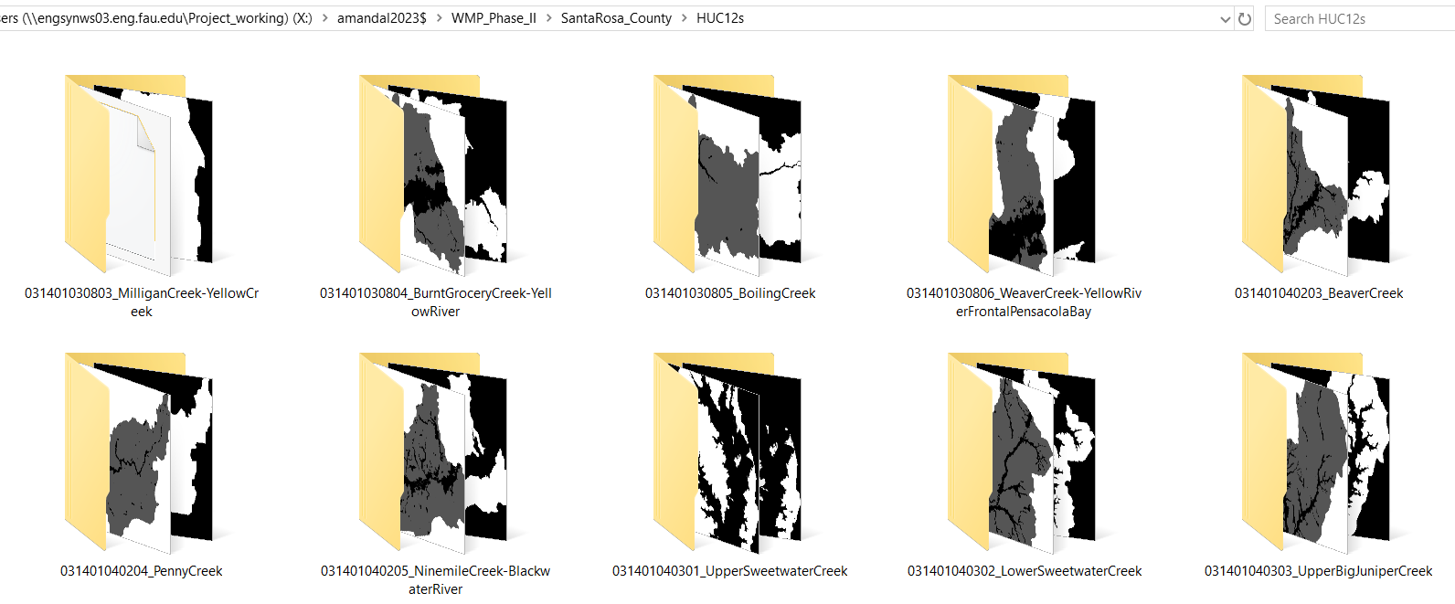

Figure 2: HUC12s folder structure

# Naming Conventions

## Vector files

All the vector files used to generate maps should strictly follow the naming conventions as described in the following table. You don’t need to clip vector files based on HUC12 boundaries unless they differ in properties based on HUC12 boundaries. These files must be inside the Client(study area).gdb file.

|  |  |  |
| --- | --- | --- |
| SN | Name | Description |
| 1 | HUC12s_Boundary | This dataset represents the HUC12s boundaries for the watershed. |
| 2 | municipalities | Municipalities Boundary |
| 3 | water_wells | Water wells |
| 4 | surface_water | Surface water stations |
| 5 | ground_water | Ground water stations |
| 6 | NOAA_tidal | NOAA tidal Stations |
| 7 | infrastructures | Infrastructures |
| 8 | drainage_networks | Flow line/ Drainage networks |
| 9 | land_use | Land use/ SFWMD_LandUse |
| 10 | land_cover | Land cover/ NLCD_LandCover |
| 11 | fema_flood | FEMA flooding zone |
| 12 | composite_score_1d100y | Composite score under 1d100y. The Composite Score layer must contain a column “CompScore” to represent the composite score values. |
| 13 | composite_score_1d100y_5ft | Composite score under 1d100y and 5 feet sea level rise. The Composite Score layer must contain a column “CompScore” to represent the composite score values. |
| 14 | critical_facilities | Critical facilities (priority of land use) /Tiers, must contain a column “Tier_no” |
| 15 | drill_down_poly | The grid layer for drill-down maps. |

Please note that you may have additional layers based on your study; please maintain them properly and describe them in Folder_Details.xls.

## Raster files

The raster files must be in GeoTIFF(.tif) format. The mosaics should be stored in a folder named Client/Community, and the files for individual sub-watersheds must be stored in the HUC12s folder organized by HUC12. The naming conventions for all mosaics and HUC12s rasters must be the same as mentioned in the following table.

|  |  |  |
| --- | --- | --- |
| **SN** | **Name** | **Description** |
| 1 | dem_ft | Digital elevation model (1-meter cell size) with vertical units converted to feet obtained from <https://apps.nationalmap.gov/lidar-explorer>. Gaps filled by mosaicking available 3-meter DEM data from Phase 1 - \\engsynws01.eng.fau.edu\Project_mastercopy\Datasets\LiDAR_DEM\DEM_3m_merged\MERGED |
| 2 | dem_resample | Resampled digital elevation model for calculations (10-meter cell size) with vertical units in feet created by resampling "dem_ft" raster dataset |
| 3 | impervious | Binary land classification of 0 = impervious surfaces, and 1 = pervious surfaces obtained from Phase 1 data - \\engsynws01.eng.fau.edu\Project_mastercopy\Datasets\Impervious\ImperviousBinary\Binary_Impervious_OK.dat |
| 4 | inundation_*<scenario>* | Probability of inundation (flood risk) Z-score surface created using a maximum headwater heights output from CASCADE2001 simulation and the "dem_ft" raster dataset clipped to any subbasins using the expression [headwater height] minus [DEM] divided by 0.46  *scenario: 1d100yr_1ft*  *scenario: 1d100yr_kt*  *scenario: 1d100yr_kt_1ft* |
| 5 | nlcd |  |
| 6 | rain_*<scenario>_in* | Estimated precipitation for a 3-day 25-year design storm obtained from \\engsynws01.eng.fau.edu\Project_mastercopy\Datasets\FL_NOAA14_Precipitation  *Scenario:* 100y1d, 25y3d, 10y1d, 5y1d |
| 7 | ssc_inch | Soil storage capacity in inches created by the expression "d2wte_ft" times "whc_ratio" times "impervious" times "water" times 12 inches (for conversion) |
| 8 | unsaturated |  |
| 9 | water | Binary classification of 0 = water, and 1 = land obtained from Phase 1 data: - \\engsynws01.eng.fau.edu\Project_mastercopy\Datasets\FL_Waterbodies\Water_Raster\Binary_Water.tif |
| 10 | whc_ratio | Water holding capacity ratio surface obtained from Phase 1 data - \\engsynws01.eng.fau.edu\Project_mastercopy\Datasets\FL_Soil\aws0_150_whc1.tif |
| 11 | wte_ft | Water table elevation with vertical units in feet generated using a multiple linear regression (specify equation used) or ordinary kriging / EBK. |
| 12 | minwte_ft | Local minimum water table with vertical units in feet created using the Empirical Bayesian Kriging (EBK) function to run an interpolation with the observed surface water stations DBHYDRO data and pseudo-station point elevations |
| 13 | d2minwte_ft | Depth in feet to the local minimum water table (surface water only) created by the expression "dem_resample" minus "minwte_ft" |
| 14 | d2wte_ft | Depth in feet of the unsaturated zone (vadose zone) soil layer created by the expression "dem_resample" minus "wte_ft" and using the conditional function, Con, to reassign negative values to zero |
| 15 | soilStorage | Soil storage |
| 16 | wte_slr_*<sea level rise>*_ft | Water table elevation plus sea level rise increase (1 ft, 2 ft, …, etc.) |

# Using Python Notebook in ArcGIS pro

A Python notebook has been developed to automate some tasks, which can be used within the ArcGIS pro-environment. The notebook has been divided into five parts; you can use all or any specific parts based on your needs.

## Importing notebook

Download the data_management.ipython into your user directory, then open it like other layers from catalog. You can use any existing ArcGIS project or start with the fresh one.

After locating the ipython file, double click on file it will open a new window with python programs. Don’t panic, it might take few time to open. After it opens you might be able to see python scripts directly or the interface as shown below. Just click on the name it will be expanded and you will be able to see the script.

To run the scripts you need to select the cell, that you want to execute then click on run. If you select any particular cell, it should look as follows. Please note that in every script, there is a variable ‘current_directory’, which holds the path of your working directory. You should adjust the path based on your user directory and study area before executing the scripts.

|  |  |  |
| --- | --- | --- |
| SN | Name | Description |
| 1 | Create parent folders | It will automatically create the parent folders in your current directory, as shown in figure1. Please note that it will only create folders and will not process any datasets. |
| 2 | Create child folders | It will automatically create the child folders in HUC12s directory, as shown in figure2. Please note that it will only create folders and will not process any datasets. |
| 3 | Create HUC12s Rasters | It will clip the raster files based on the HUC12 boundaries and store in the respective folders. Please note that it assumes you have already maintained the mosaic rasters with proper naming conventions in the respective directory. i.e., client/community directory. |
| 4 | Create mosaic Rasters | It will mosaic the raster files for your study area and store in the respective folders. Please note that it assumes you have already maintained the HUC12s rasters with proper naming conventions in the respective directory. i.e., HUC12s. |
| 5 | Generate Folder_details.xls | It will generate a Folder_Details.xls file in your current directory based on the files and folders available in your current directory. |

